**Data Movement’s Follow the Sun (FTS) - Handoff Tool & Process**

**Guide for Support Engineers**

This Guide assumes the following:

* You are a support engineer active on VDM.
* You’re familiar with the current [Big Data / Data Movement handoff process](https://dev.azure.com/Supportability/Big%20Data/_wiki/wikis/Big-Data.wiki/306262/Case-Handoff-Process)

What to Do When You Need to Transfer a Case  
Each of these steps has an explanatory section in the guide below.  
These steps should be completed **before** your handover call time if at all possible.

1. Add case transfer notes to your case as usual.
2. Check the list of FTS requests in the next handover call.
3. If your case is in the list, select and complete the FTS request up to the “Ensure Summary” stage. Save.
4. If your case is not already in the list, manually create an FTS request and complete the request up to the “Ensure Summary” stage. Save.
5. Join the handover call to confirm your case will be transferred or reach out to your case assignment lead to manage or vouch for your case at the call.

Case Transfer Notes

These notes should be added to your Service Desk case notes before you transfer the case.  
  
Summary  
=============  
<Short description that outlines the full issue at a glance. And a brief outline of what you and/or the customer have just done and your current conclusions.>

Next Steps:  
=============

Cx:

1. <List of next steps that the customer will take.>

MSFT:

1. <List of next steps that case owners or collaborators will take.>

ICM or Partner Ticket  
=============  
<If you have an ICM or product team ticket or a ticket with a partner team, add it here! If not, you can leave this section out.>

Research:  
=============

<Any articles, logs, or screenshots you referenced during your troubleshooting.>

Ticket's checklist  
=============

Customer Reachable?:Yes/No  
Waiting for RCA?:Yes/No  
Customer accept English Support?: Yes/No  
Now the issue is pending on?: PG/CSS/Customer  
IcM ID?:  
<Reason for Critsit:>

How to Access the FTS Tool and Handover Call Menu

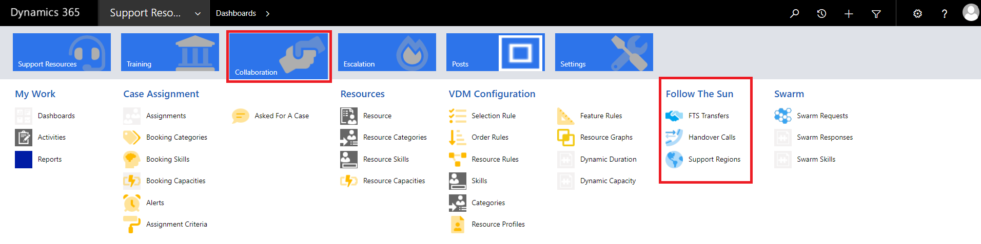

1. In Edge Browser:  [https://crmglobal.corp.microsoft.com/GLBCRMSUP/](https://crmglobal.corp.microsoft.com/GLBCRMSUP)
2. Go to **Collaboration**, then **FTS Transfers** under “**Follow The Sun**” title
3. Select “Handover Calls”  
   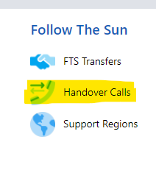
4. Search “Data Movement”
5. Choose your next handover call.  
   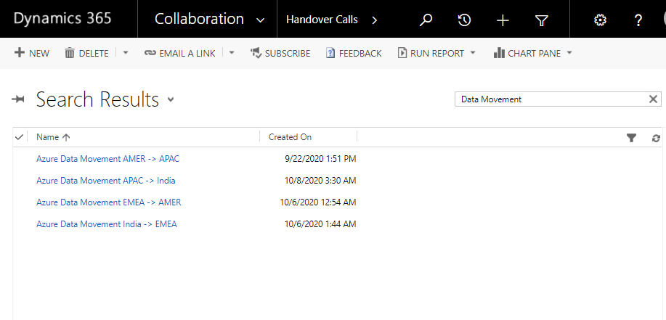

Handover Call Menu

In this menu you can see all the FTS transfer requests.  
  
These requests are added by one of two methods.  
1. Automatically – Based on Severity and Status, FTS will automatically create a request.

2. Manually – An engineer creates a transfer request for their case.  
  
Below is a description of all the parts of the handover menu.

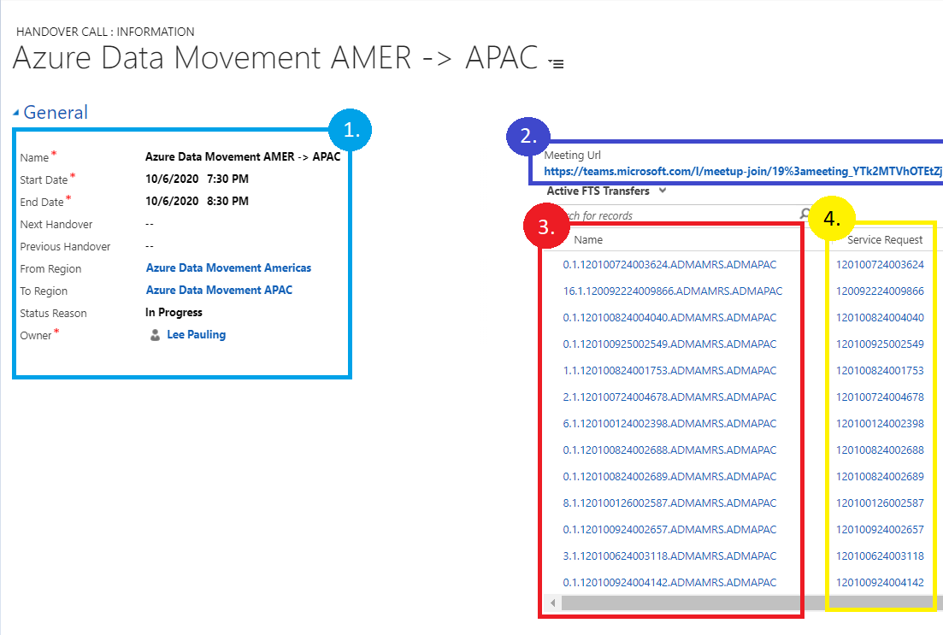

* 1. General handover call time and information.
  2. Handover meeting URL. (This is a link to our existing handover teams meetings.)
  3. Links to the FTS requests for each case.
  4. Service request number associated with each case.

To modify/update an FTS request, select the link to the FTS request for your case number.

Cases Automatically Added to FTS

Cases that meet the criteria below will be automatically added to the FTS list to be approved for transfer.

* Sev A “CritSit” cases not marked as “Waiting for Confirmation”
* Sev B and 27x7 flagged cases not marked as “Waiting for Confirmation”

How to Add a Case to Transfer Manually

Steps to add your case to the transfer list.

1. Open CRM in Edge Browser:
2. Search your case number in the search bar on the top right.  
   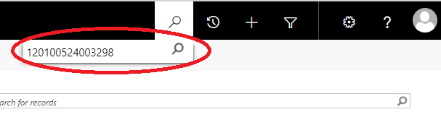
3. Select your case under “Service Requests”  
   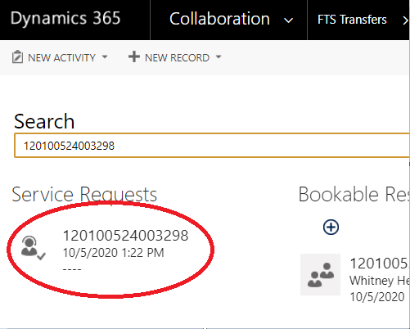
4. In the top bar, click the drop-down next to the case number.  
   
5. Select “FTS Transfers”  
   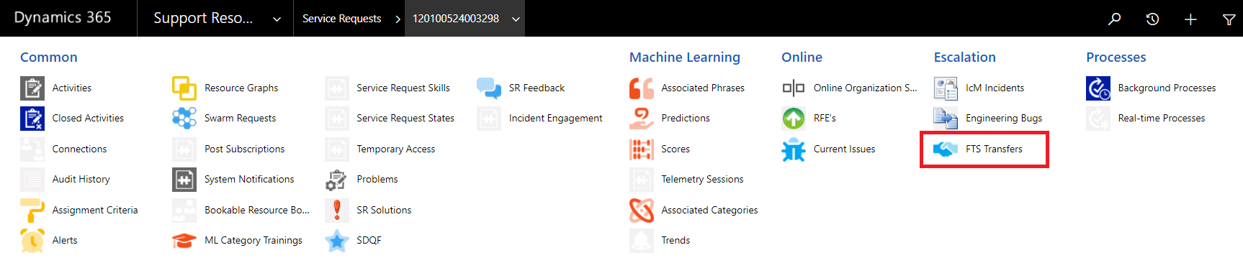
6. Select “+ Add New FTS Transfer”  
   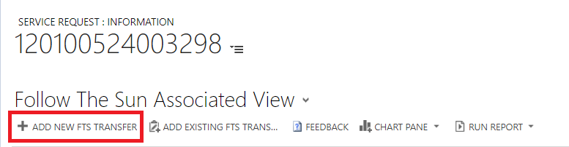
7. Fill out the FTS form with the appropriate information through to “Ensure Summary” by filling all fields with red asterisk (*) and then selecting “Next Stage”  
   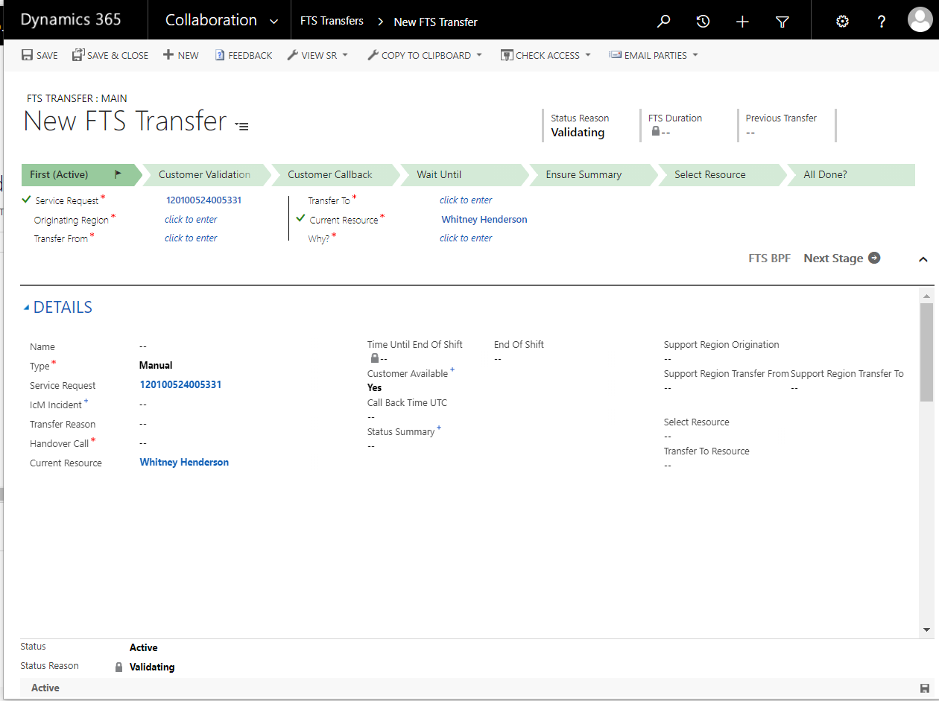  
     
   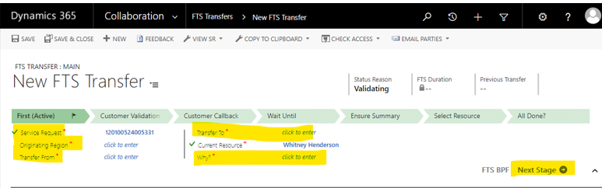  
     
   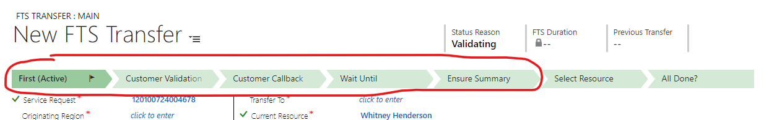
8. Under “Ensure Summary” which is where you will fill out the notes section of the handover, use the summary to explain why the case needs to be transferred.  
     
   **The summary section in FTS does not need to be your last case notes.**Your case notes are still very important, and should continue our current handover best practices by covering the issue, current stats and next steps.  
   **However, the summary section in FTS is there to cover why the case needs to be transferred.  
     
   Template for Transfer Summary:**  
   Reason for Transfer  
   ============================  
   <Provide brief summary of reason for transfer.>  
     
   Next Steps for Case  
   ============================  
   <List or summary of the next steps that need to be taken on the case.  
     
   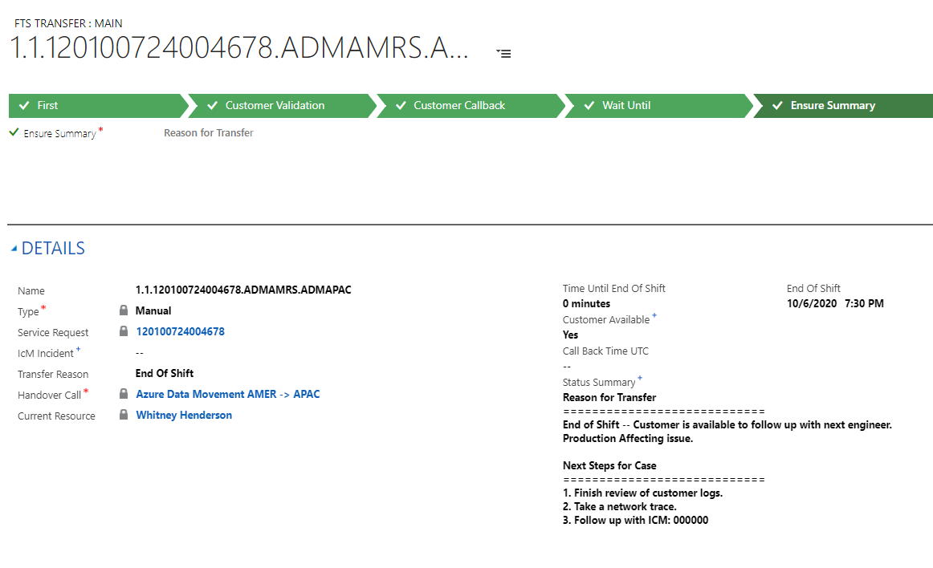
9. At the handover call time, your case assignment lead will review the handover, select a resource, and process the transfer.  
   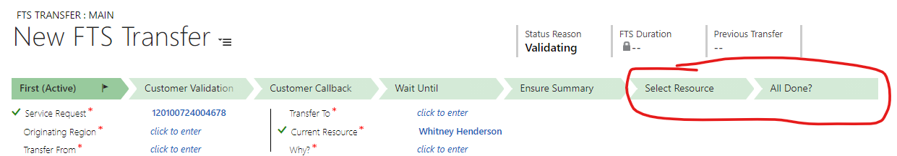

How to Skip a Region in FTS

Let us say, for example, you have a case in AMER that needs to skip APAC and go straight to EMEA.  
You can use FTS to perform this transfer.  
  
1. You fill out your FTS transfer as normal, and in the “Transfer To” section, you pick THE NEXT REGION. Choose the next handover call and the next region, as the case will still need to pass through that region to get to the region you need. So for our example, you would still choose “APAC” as the next region, and the APAC handover call as the next handover call.  
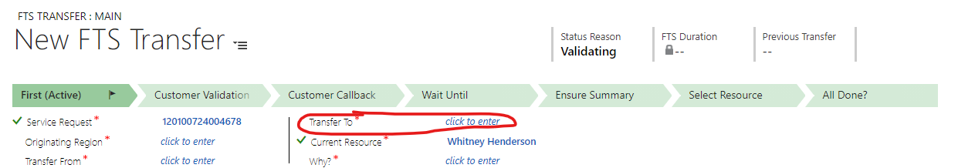  
  
2. Fill out the rest of the transfer as normal, and in the summary notes specify that the case needs to skip a region and why.  
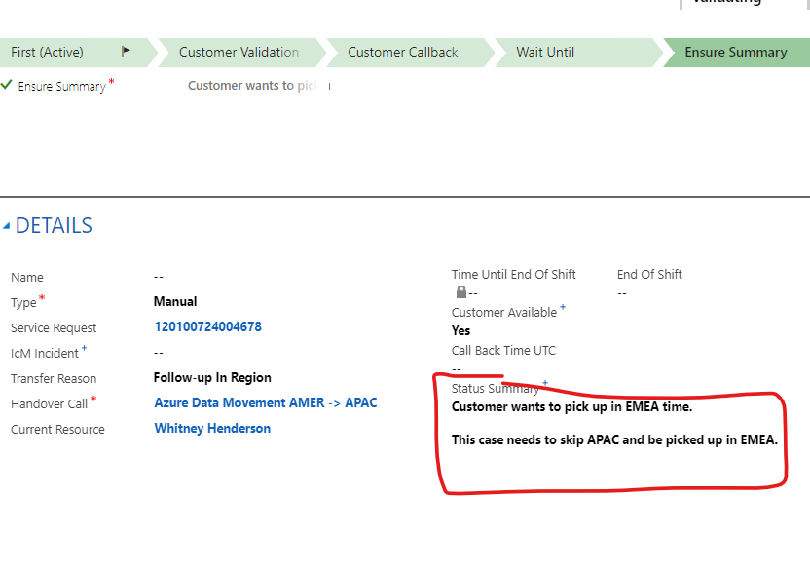  
  
3. Then in the “Select Resource” Section the Lead will see that the case needs to skip the region and choose “Skip”. The transfer will then skip the region and be moved to the next, where the leads can choose to process the assignment for that region.

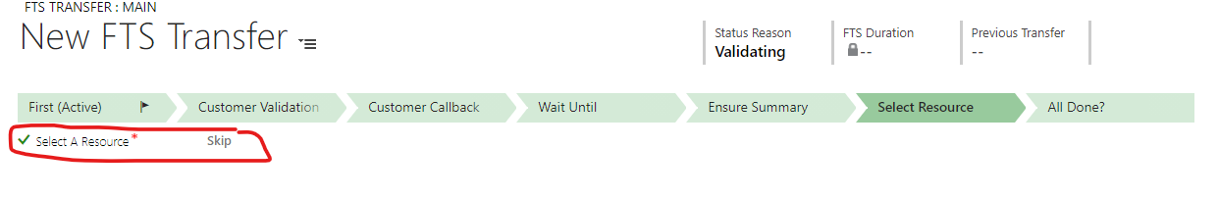

How a Case is Transferred After It Has Been Added

A case that has been added, automatically or manually, to the list will be approved for transfer by a lead, as shown in steps 7 and 8 of the guide above.

After it has been approved for transfer VDM will find a skilled engineer in the destination region and will automatically assign that engineer, like for any other case.

If a case has been previously transferred, FTS will favor transferring to an engineer who has owned the case in the past.

Handover Calls

Handover calls still exist and are an integral part of FTS.

During the handover calls our leads will review all cases slated for transfer and select a resource (either selecting “Automatic” to allow VDM to assign to an available resource or “Manual” to choose a specific resource to take a case.)

If a case slated for handover needs to be discussed, the handover call will be the teams chat/location to facilitate the discussion, much as our calls today.  
  
When we initialize FTS, the handoff calls should be joined to make sure cases are appropriately transferred.  
  
As we become familiar with the process, the handover calls can be used to facilitate discussion of more interesting cases.

Troubleshooting

Can’t Update Your FTS Request?  
  
Issue:  
You cannot update your FTS Request, can’t save it, and your stages show little lock icons.  
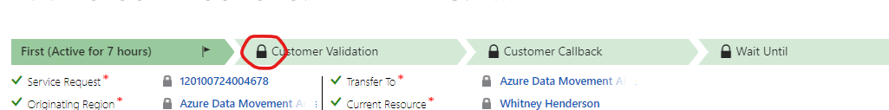  
Resolution:  
Your FTS request is inactive. You can see this at the bottom of the page.  
Select “Activate” to continue working on your FTS request.  
